MA Strategic Fashion Marketing 23-24
PTES Overview

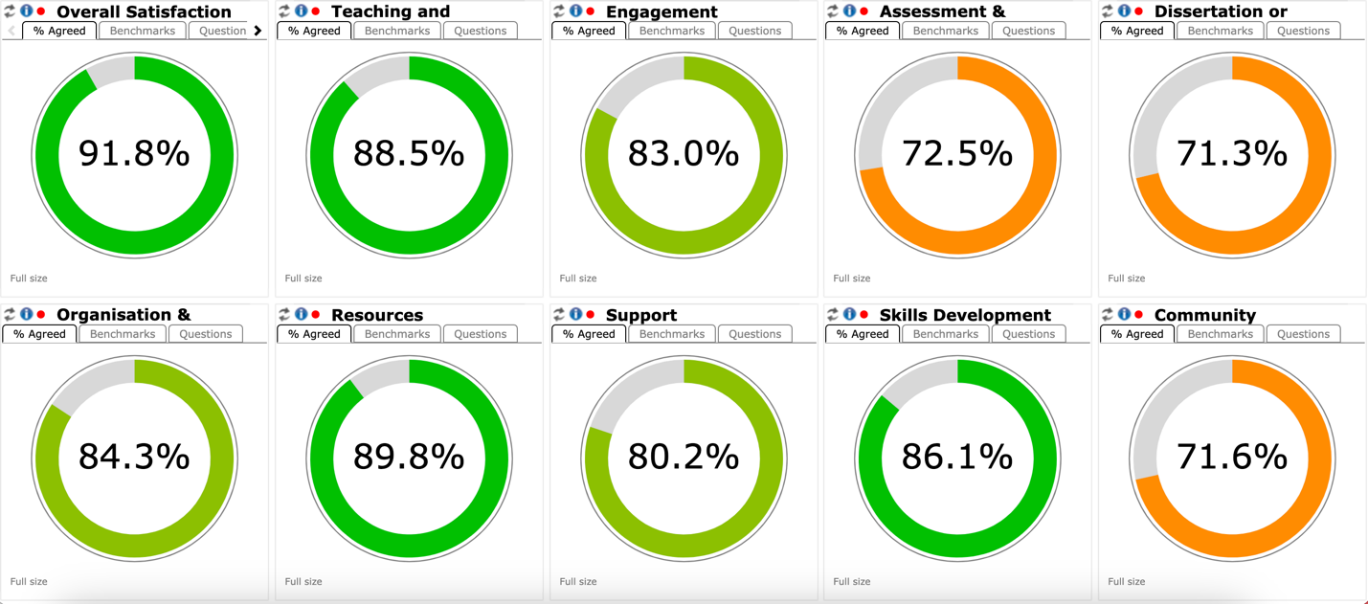

RESPONSIBILITY ON ONESELF:
- i think this is because I have not checked or made any effort to find out
- I've not connected well with other students.

DESIRE TO CONNECT WITH OTHERS:
- I would have liked to have had some more events outside of teaching with other students and teachers, but I think there will be more to come over the next few months
- Other students seems overall really busy outside of this MA and are not willing to exchange more necessary than during the seminars. In October I've tried to set up an instagram account for everyone to share ideas on Fashion and keep it as a memory for this MA; but only one person came back to me and we ended up giving up on the idea
- I would love to have more networking events!
- I would love to collaborate with other students in LCF more often or across the three marketing programs. I think group work is very valuable especially for our industry
- I was expecting more classes to be SFM-only. There are so many people in the programme I'll never know because we don't have enough opportunity to connect as a class. I also think it may have been good to completely switch up the seminar groups in semester 2 so we have the opportunity to connect with others - the seminars are definitely where most people make friends. For Collab Challenge, it was great to meet students from other specialisms. I would have liked to hear the presentations/responses from the other groups, and not keep us so separated. It would have been interesting and beneficial to hear how other students approached the same project.

NEGATIVE EXPERIENCES:
- I don’t feel the course is very interactive with lecturers and other students.
- Regarding community and belonging, I want to share my experience honestly. While academics are all well and good at this college, I've struggled with feeling isolated and unwelcome at this college. Despite my efforts to communicate and engage with my classmates, I consistently felt like an outcast, which has taken a toll on my mental health and left me feeling lonely. Joining the course three weeks late put me at a disadvantage, as everyone had already formed groups and friendships. Despite my hesitation, the lack of welcoming gestures from my peers exacerbated my feelings of alienation. I've tried initiating conversations and joining activities, but I've never felt truly included. Even individuals from my own country, India, seemed to have formed their own cliques without extending a hand to include me. All of these people always saw me sitting alone, going around alone, but they never cared to welcome me involve me for anything. They always made me feel like the show had already started and I came out of nowhere. Despite my visible confusion and isolation, no one reached out to offer assistance or empathy. I was hesitant already, but the ignorance of the classmates and no sense of welcoming nature towards me made me feel the worst. I was never this person that i have become. Now, I don't approach anyone anymore or try to initiate anything unless needed for a group work or seminar. I have accepted the fact that there are no friends of me in this college. I've grown weary of this experience, as attending this college was once a dream of mine. Unfortunately, I've found it to be the most challenging aspect of my life, socially speaking. The only reason I hate being at this college is because I feel left out. I long for the sense of belonging and camaraderie that seems to elude me here. I am so tired of this. I miss the warmth of home and the joy of social interaction. Sadly, I'm not sure if I'll ever regain the enthusiasm I once had for attending this college. I just wanna go home!

Initial PTES Themes and Sub-Themes

1. Responsibility on Oneself
- Self-reflection: Some students attribute their lack of belonging to personal inaction or reluctance to engage.
  - Example: "I think this is because I have not checked or made any effort to find out."
- Limited effort to connect: Students acknowledge difficulties stemming from not taking the initiative to bond with peers.

2. Desire to Connect with Others
- Need for social events: Students express a strong desire for structured networking opportunities outside the academic setting.
  - Example: "I would love to have more networking events!"
- Peer collaboration: Opportunities to collaborate across programs and specialisms are viewed as highly valuable for fostering connections and professional growth.
  - Example: "I would love to collaborate with other students in LCF more often or across the three marketing programs."
- Insufficient opportunities within classes: Students feel there aren’t enough moments to engage with their full cohort, particularly through activities like group projects or mixed seminar groups.
  - Example: "I was expecting more classes to be SFM-only. There are so many people in the programme I'll never know because we don't have enough opportunity to connect as a class."
- Digital connection efforts: Attempts to establish virtual platforms for communication (e.g., Instagram groups) often failed due to low participation.

3. Negative Experiences
- Isolation and exclusion: Feelings of alienation dominate, especially for those who joined late or struggled to break into existing social circles.
  - Example: "Joining the course three weeks late put me at a disadvantage, as everyone had already formed groups and friendships."
- Cultural and cliquish divides: Some students noted cultural cliques preventing inclusive interactions.
  - Example: "Even individuals from my own country, India, seemed to have formed their own cliques without extending a hand to include me."
- Mental health impacts: The lack of belonging has profound effects on students' mental health, leading to loneliness and diminished enthusiasm for their studies.
  - Example: "I consistently felt like an outcast, which has taken a toll on my mental health and left me feeling lonely."
- Limited faculty interaction: A perceived lack of interaction with lecturers compounds the sense of detachment from the academic community.
  - Example: "I don’t feel the course is very interactive with lecturers and other students."

