Name: Nina Van Volkinburg

Wednesday (ONLINE)

Tutor: Montana Willamson

Word count: 1,559 (exclusing reference list)

1.1 Introduction
Given the focus on understanding and appreciating each other’s experiences and diverse backgrounds, for me, this unit as well as proposed intervention, can be represented by the quote from Sydney J. Harris: “The purpose of education is to turn mirrors into windows.”
The second unit of the Postgraduate Certificate (PGCert) has provided an important opportunity to reflect deeply on our roles as educators and the broader inequalities and injustices embedded within society. The opportunities for reflection within this unit (See Blog posts 1-3) was critical given the historical and ongoing injustices that impact marginalised groups. Engaging in challenging discussions and immersing myself within provocative readings with peers has been instrumental in my personal and professional growth. This development has allowed me to consider, design and begin to implement an intervention aimed at enhancing inclusivity and accessibility within my teaching context at LCF. The intervention, grounded in the principles of intersectionality, focuses on leveraging e-learning materials to support students with diverse needs.

1.2 My Positionality
My approach to higher education is heavily influenced by social constructivism and the theories of Paulo Freire, who emphasised the importance of co-creation and dialogue in the learning process. Freire's (1970) work highlights that students actively participate in their education, which necessitates a classroom culture that fosters inclusivity and respect. To build such a culture, I make concerted efforts to recognise and celebrate the diverse backgrounds of my students. For example, I write personalised holiday cards and extend my best wishes for various cultural celebrations, such as "新年快乐" (Happy Chinese New Year), Happy Eid, Happy Easter, and Happy Diwali. These gestures, albeit small, do help create a sense of community and trust. Intersectionality, as articulated by Crenshaw (1990), is crucial in understanding how various aspects of a person's social and political identities intersect to create unique experiences of discrimination and privilege. This perspective informs my teaching practice, recognising that students' experiences are shaped by the interplay of multiple identity categories.

1.3 My Reflexivity
As highlighted by Bayeck (2022), positionality acknowledges the influence of one's background, experiences, and social identities on their perspectives and interactions. My own reflexivity is captured in Table 1, which outlines my privileges and sources for discrimination within a UK context. Acknowledging my whiteness, which has afforded me structural advantages and race privilege (Frankenburg, 1993), is essential in understanding my standpoint and helping me play an active part in closing inclusivity gaps. Hence at the core of my future intervention is co-creation where students, together with staff, have a space to create knowledge together.
Category | Identity
Gender | Female
Sexuality | Heterosexual
Socio-Economic Class | Middle-Class Background
Race | Caucasian
Age | 30
Geographic Background | Expat / Cosmopolitan
Language | Native English Speaker (Non-British)
Disabilities | None
Table 1: Author’s Reflexivity

2. Intervention Details

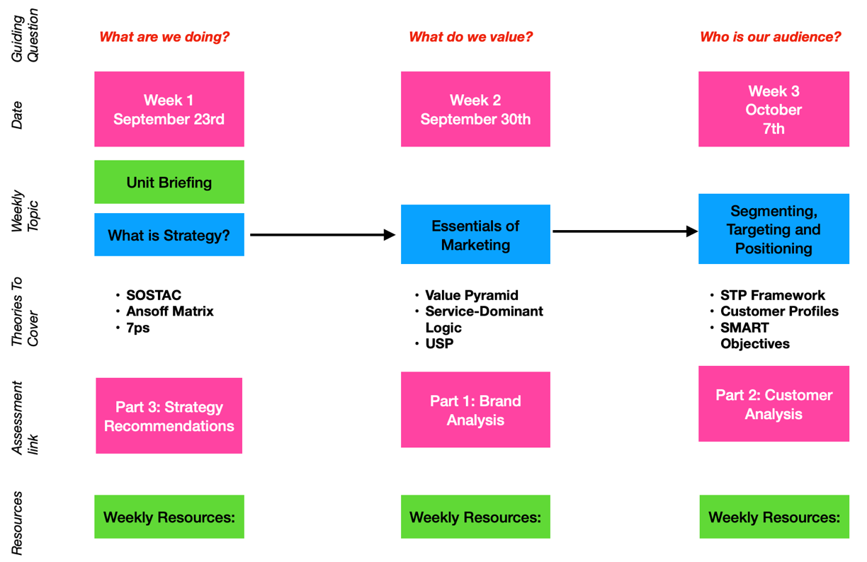

Fig. 1: Mock up of Intervention Example: Visualising the Scheme of Work
Immersing myself in the literature on intersectionality and disability, along with considerations of faith and race, has profoundly influenced my teaching practice. It has become evident that accessibility is a critical aspect for the materials we provide to students. At the London College of Fashion (LCF), where I lead a diverse and international cohort, many students face barriers to learning due to language differences and other factors. My intervention aims to explore how e-learning technologies can enhance the learning process for students affected by physical disabilities, neurodiversity, and religious absences (Figure 1). Specifically, I aim to expand on our unit Scheme of Work document by making it more visual, collaborative, and dynamic as currently this document is black text on a white background, very text heavy and confusing to understand what is being discussed week on week (Figure 3). I believe this intervention is needed to 1) provide students a better understanding of a unit’s content 2) give students more user-friendly and accessible materials to complement their MA studies and 3) give student’s the flexibility to catch up on any missed work by following a visual learning journey. The intervention connects with principles from Richards and Finnegan (2015) where “student-centred learning in the curriculum can create greater opportunities for students to have a sense of ownership over their environment.” The intervention will focus on Phase 1 as can be seen in Figure 2, but I aim to expand the resource into a tool in upcoming years.
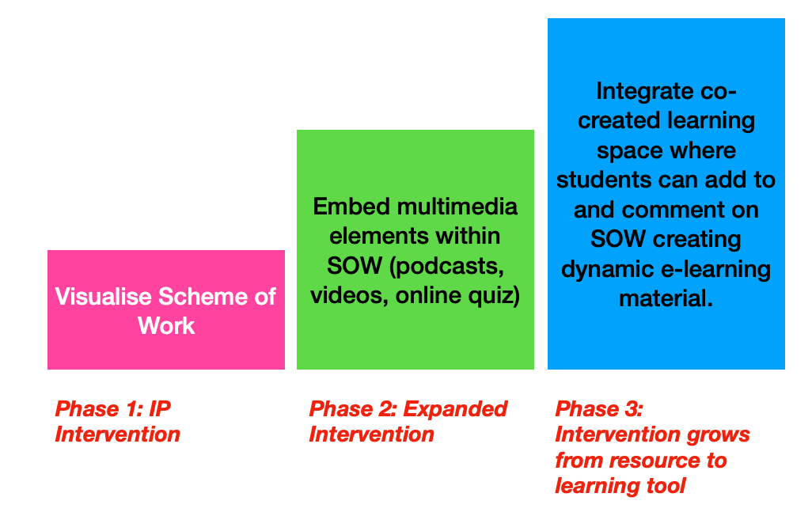

Fig. 2: Intervention Phases (IP focus on Phase 1)

2.1 Objectives of the Phase 1 Intervention
- Enhance Accessibility: Ensure that PG Marketing students, regardless of physical abilities, neurodiverse conditions, or religious commitments, have equitable access to unit Scheme of Work.
- Support Independent Learning: Create a learning environment where students can independently track their own progress and engage with the material on their terms.
- Create a Dynamic Learning Experience: Utilise multimedia and interactive tools to make learning more engaging and effective.
The objectives additionally point towards further development in creative a co-learning virtual space in future (Phase 2-3).
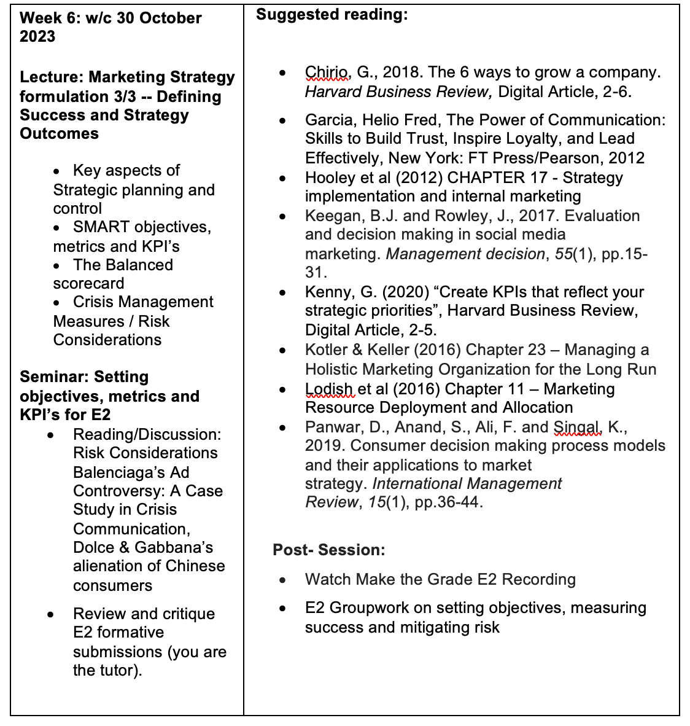
Fig. 3: Current Scheme of work example (p. 7 of 21) which in the past has caused confusion

2.2 Detailed Intervention Plan
- Visual Mapping of Block 1 Unit “Fashion Marketing Strategies”
  - To address diverse student needs, I will visually map out the Block 1 unit "Fashion Marketing Strategies" in line with Scheme of Work. This will include a week-by-week outline of key learnings, readings, provocation questions, and essential frameworks. The visual map will serve as an organised guide, facilitating easier navigation of the curriculum.
- Embedding Multimedia and Interactive Tools
  - Hyperlinks to Supplementary Materials: Provide direct access to additional readings, articles, and resources that complement each week's topics.
  - Padlet for Anonymous Questions: Create a Padlet board for students to post questions anonymously, encouraging participation from those hesitant to speak up in class.
- Ensuring Seamless Continuity for Absent Students
  - For students who cannot attend lectures or workshops due to physical disabilities, neurodiverse conditions, or religious commitments, the intervention will ensure continuity in learning. The mapped-out unit and embedded technologies will allow students to monitor their progress, providing clarity on their achievements and focus areas. It will support students in independently navigating the unit, reducing the discomfort or stigma of seeking help for falling behind.
The primary goals of this intervention are to enhance students' understanding of course content, improve their comfort and confidence through better accessibility, and provide a more enriching and inclusive learning experience.

3. Feedback and Evaluation

3.1 Feedback from Stakeholders

Tutor Feedback
When presenting my intervention to my tutor (June 18), I received positive feedback but was reminded of the importance of not attempting to implement everything at once. Prioritising the visualisation of the Scheme of Work was suggested as a manageable starting point. Additionally, my tutor highlighted the need to consider accessibility issues related to technology platforms, as some students may face challenges accessing certain platforms like Moodle from abroad (e.g., in China). This feedback led me to consider providing a physical copy of the Scheme of Work visualisation to ensure accessibility for all students.

Peer Feedback
Presenting my idea to my peer group (June 25) revealed a shared focus on accessibility in our interventions. They provided positive feedback and emphasised the importance of avoiding excessive text on documents to prevent confusion. Additionally, their feedback led me to consider future additions to the dynamic scheme of work (Fig. 2) including:
Explanatory Videos: Record and upload videos explaining key academic concepts, aiding students who struggle with language barriers or need to revisit complex topics.
Podcasts and Multimedia Content: Include varied formats like podcasts to present information, catering to different learning preferences.

Colleague Feedback
Colleagues at LCF supported the idea, noting the need to integrate more online resources to complement offline experiences. They recognised the potential of the intervention to enhance student engagement and learning.

Student Feedback
Current MA students expressed appreciation for the intervention idea, stating that it would help contextualise their studies in a more meaningful way. They valued the idea of a collaborative and fluid document rather than a static one, which would foster better connections between different blocks.

Overall, the intended impact on students and staff would include:
  - Reduce barriers for Physical Disability: Multimedia content, such as videos and podcasts, allows students with physical disabilities to access materials at their own pace and in formats that suit their needs, reducing physical barriers to learning.
  - Reduce barriers for Neurodiversity: Structured and visual mapping of the unit helps neurodiverse students organize their learning process. The varied presentation of content caters to different cognitive strengths and learning styles.
  - Reduce barriers due to Religious Absences: Students who miss classes for religious observances can access recorded lectures and supplementary materials, ensuring they do not fall behind. This flexibility respects their religious commitments.

5. Conclusion
As my tutor advised, it is essential to focus on what is manageable and prioritise effectively. I will begin by implementing the intervention in the Block 1 unit "Fashion Marketing Strategies," shared across all PG Marketing courses. This newly validated unit provides an excellent opportunity to gather feedback from the teaching team and students. This intervention can then serve as a foundation for a larger Action Research Project (ARP) exploring how online tools can further support in-person teaching, enhancing accessibility and inclusivity. By continuously reflecting on and adapting our teaching practices, we can strive towards a more inclusive and supportive educational environment for all students.

References
Bayeck, R.Y. (2022) Positionality: The Interplay of Space, Context and Identity. Journal of Qualitative Methods. 21, p.1-9.

Crenshaw, K. (1990) Mapping the margins: Intersectionality, identity politics, and violence against women of color. Stanford Law Review 43, p1241.

Frankenburg, R. (1993). White women, race matters: The social construction of whiteness. Routledge.

Freire, P. (1970) Pedagogy of the Oppressed. New York: Bloomsbury Academic.

Richards, A. and Finnigan, T. (2015) ‘Embedding equality and diversity in the curriculum: An art and design practitioner’s guide.’ York: Higher Education Academy. Available at: https://www.advance-he.ac.uk/knowledge-hub/retention-and-attainment-disciplines-art-and-design

